TRAINING AND PLACEMENT CELL
ACADEMIC YEAR 2024-2025
Thrive Academy Puducherry, placement orientation program held on 26.09.2024

Happy greetings dear team
The Training and placement Cell of Achariya Arts and Science College conducted a session on Career Development on 26.09.2024 for all three years of UG and PG students. Mrs. Mythli, Founder and Director of Thrive Academy delivered a lecture focusing on how students need to focus on their personality development and improving their spoken English. She also gave a detailed picture on remote freelance work and Earn-while-you-learn jobs.
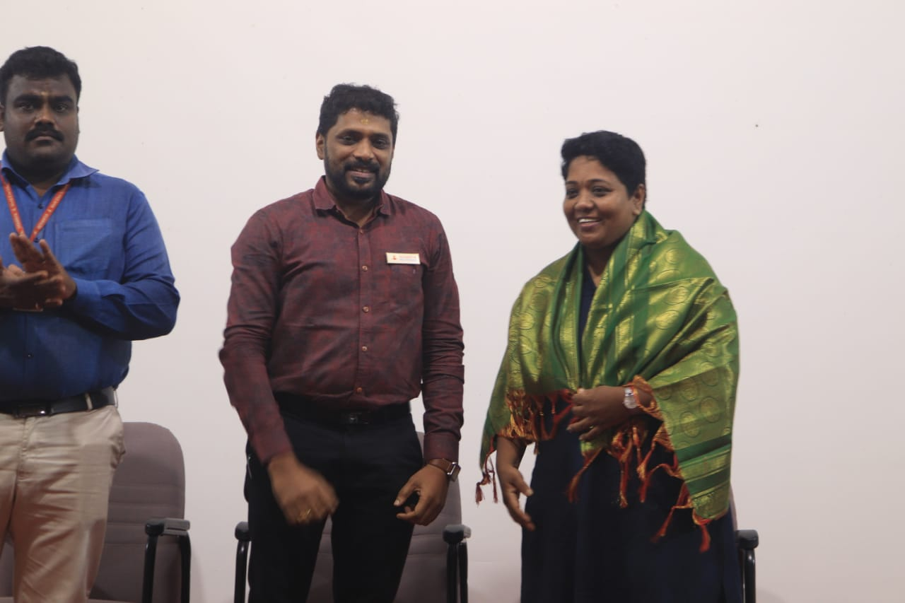
We extend our sincere gratitude to our Esteemed MD Sir and Respected Principal Dr. S. Vimalanand sir and all Heads and Faculty of the college for their continuous cooperation and support.

